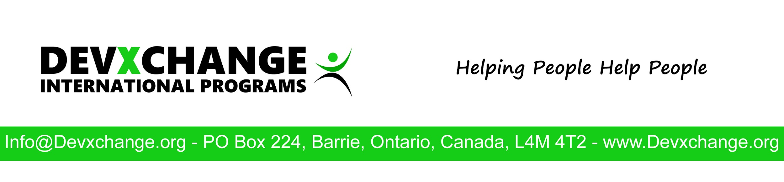
Project Evaluation

Evaluator’s Name:
Project:
Country:
Location in the Country:
Date:

Implementing Partner
- Is the implementing partner registered with the government in their country (Charity, Organization, Church, NGO, etc.)
- When was it registered?
- Does it have an active Board or Advisory Committee?
- Are Board Members or Advisory Committee paid?
- Is the Board or Advisory Committee made up of family members?
- Does Board or Advisory Committee keep minutes of meetings?
- How Often does the Board or Advisory Committee meet?
- Do you have confidence in the implementing partner’s ability to achieve the objective of the project? What challenges might they face?
- Who has oversight of the implementing partner in the host country and what is the process?(Government Agencies, Church Denomination etc.)
- What is the role of the government in regulating or monitoring agencies like this one?
- Are expectations of the implementing partner realistic with that of the Devxchange Lead Member in terms of scope, funding, and time commitments? If not, please describe.
- Is the Project Director or project staff paid by funds raised from Devxchange? If yes, please provide details.
- What is the Name of the project Director?
Project
- Rate how effective the project activities overall have been at reaching their goals.
- What challenges have been identified in reaching the objectives and how will they be overcome?
- What are the long term plans to make this project sustainable?
- Is the Devxchange Lead Member involved in project planning?
- Are there any other related needs or activities that have arisen or have been identified that the project did not address?
- Are all Devxchange reports and proof of transfers up to date?
- Are other agencies working in the area doing the same thing as the implementing partner? If yes, please provide details.
- How is the government engaged to meet the needs of the area?
- How does this project compliment other efforts to address the needs?
- What are the main points of conflict in the area (religious, tribal, land, water, resources)
- Have any new opportunities been identified for collaboration or expansion?
- State some of the promising practices or specific success stories that demonstrate the significance and difference the project is making.
Finances
- Is there additional project funds outside of the funds raised by Devxchange. If yes, who and what activities or percentage of activities do they cover.
- Is Devxchange the principle source of funding for the project?
- Does the implementing partner have an audited financial statement?
- Are audited statements required for reporting to the government?
- Who is responsible for project accounting?
- How are finances recorded and what accounting system is being used?
- Does the project have a dedicated bank account for donations registered to the organization?
- Are backup reports, receipts, and documentation available if needed?
- Who authorizes expenses for this project and what is the approval process?
- Is the Devxchange project leader involved in budgeting?
- Are expenses in line with the budget?
- Is DevXchange meeting the annual project financial goal?
Child Protection
Assessing The Risks
- Does the Project work with children?
- Is the Project located in an area where child sex tourism is known to occur?
- Does the Staff help children complete washing and hygiene tasks?
- Does the Staff use social media for awareness raising and fundraising?
- Does the Project regularly hire or use overseas volunteers?
- Does the Project organize visits for overseas volunteers?
Strategies/Practices in Place to Lower the Risks
- How are visits to the project controlled and restricted?
- How are volunteers recruited by Lead Member screened and supervised?
- How does the Implementing Partner screen visitors that are not connected to the Lead member?
- Are visitors accompanied by a staff member at all times?
- Is permission granted before photos are taken or used in publications?
Photo Evidence
Caution: Ensure photography is permitted in the location and always ask for permission prior to taking any photos while overseas.
Provide photos of the following:
- Location of project site
- Staff / Volunteers of the project
- Beneficiaries or participants
- Project activities

